Building At Borivali.

Project Details
- Project Name: RaviRaj- Royal
- Location: Borivali.
- Project Type: Residential building refurbishment
- Design Firm: Wall Voids Architects
- Status: Completed

1. Project Overview
An existing residential development was refurbished to create a stronger contemporary identity and an improved arrival experience. The intervention focused on the entrance, podium façade, commercial frontage, common lobby and lift lobby. New architectural finishes, lighting, landscaping and signage were introduced while retaining the original building structure.

3. Design Concept
The design concept focuses on transforming an existing building through selective architectural and interior interventions rather than major structural changes. A coordinated palette of grey marble, dark accents, warm metallic details, greenery and lighting creates continuity from the street entrance to the lift lobby. The result is a modern, refined and welcoming residential environment.
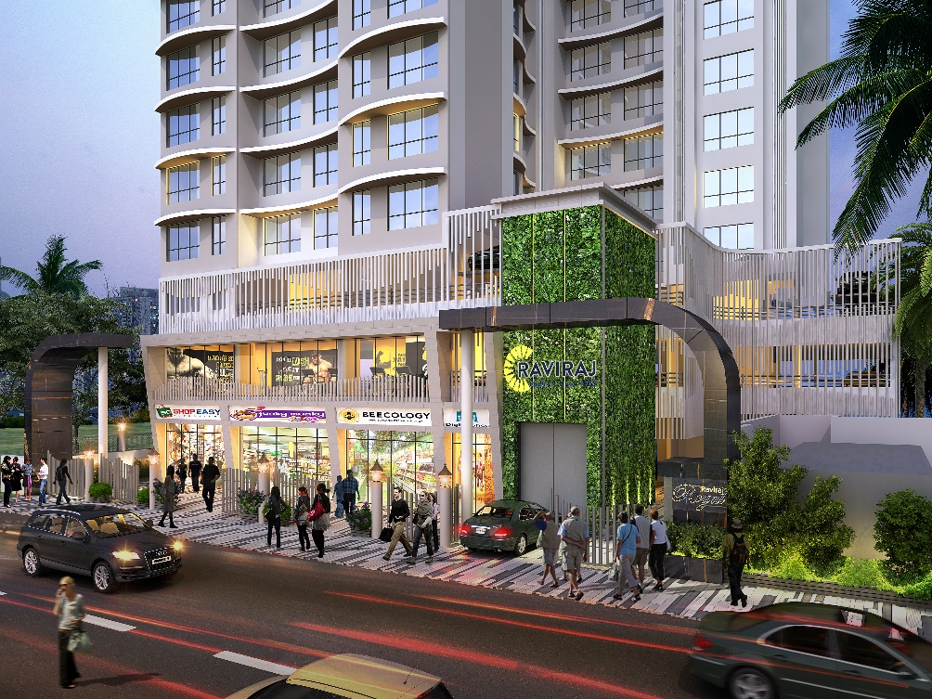

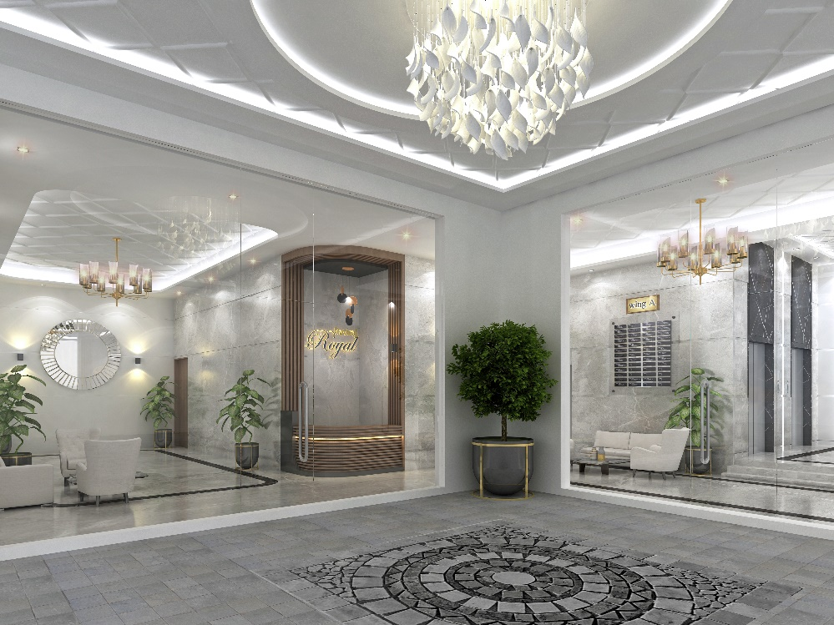
Image 2. Main Lobby.
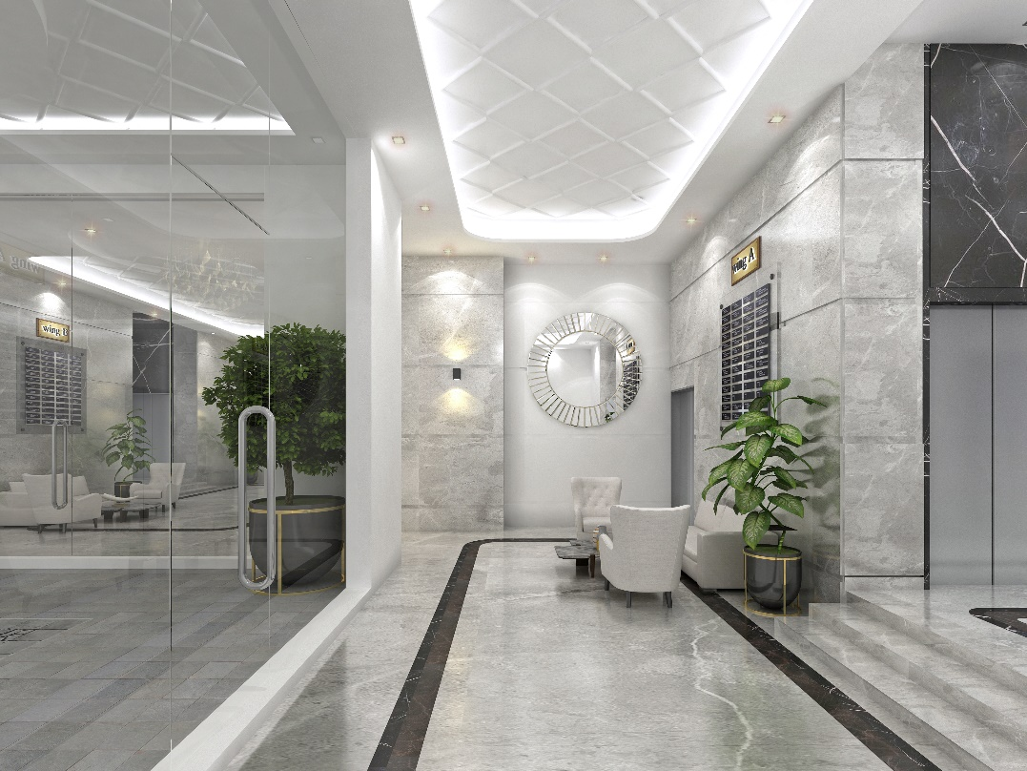
Image 3. Common Lobby.

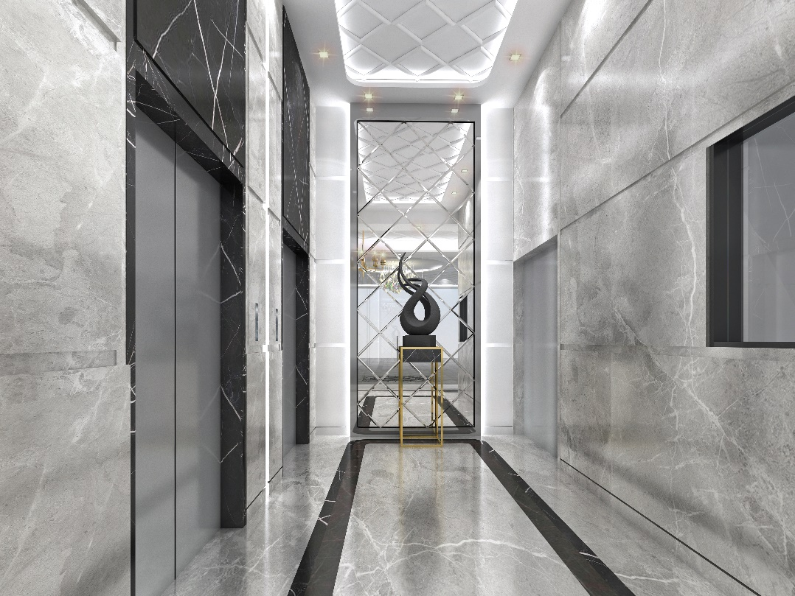
Image 4. Lift Lobby.

